1. Build a platform
• operating system: Ubuntu 18.04 server (64-bit)
• Database: SQL Server 2019
• contact access RTC server directory: /home/ubuntu/RTCServer
•IP:www.qiyeim.com

2. Install SQL Server
Note: To ensure optimal SQL Server performance, your computer should have at least 4 GB of memory. To download Ubuntu, visit the Ubuntu download website.
curl https://packages.microsoft.com/keys/microsoft.asc | sudo tee /etc/apt/trusted.gpg.d/microsoft.asc
curl https://packages.microsoft.com/config/ubuntu/20.04/mssql-server-2019.list | sudo tee /etc/apt/sources.list.d/mssql-server-2019.list

sudo apt-get update
sudo apt-get install -y mssql-server

sudo /opt/mssql/bin/mssql-conf setup
Enter 3, select the Express version, and enter your username and password
systemctl status mssql-server --no-pager

sudo su
curl https://packages.microsoft.com/keys/microsoft.asc | sudo tee /etc/apt/trusted.gpg.d/microsoft.asc

Download software packages for OS versions
#Select only the following option that matches your OS version
#Ubuntu 16.04
curl https://packages.microsoft.com/config/ubuntu/16.04/prod.list | sudo tee /etc/apt/sources.list.d/mssql-release.list

#Ubuntu 18.04
curl https://packages.microsoft.com/config/ubuntu/18.04/prod.list | sudo tee /etc/apt/sources.list.d/mssql-release.list

#Ubuntu 20.04
curl https://packages.microsoft.com/config/ubuntu/20.04/prod.list | sudo tee /etc/apt/sources.list.d/mssql-release.list

#Ubuntu 22.04
curl https://packages.microsoft.com/config/ubuntu/22.04/prod.list | sudo tee /etc/apt/sources.list.d/mssql-release.list

exit
sudo apt-get update
sudo ACCEPT_EULA=Y apt-get install msodbcsql17
sudo ACCEPT_EULA=Y apt-get install mssql-tools
echo 'export PATH="$PATH:/opt/mssql-tools/bin"' >> ~/.bash_profile
echo 'export PATH="$PATH:/opt/mssql-tools/bin"' >> ~/.bashrc
source ~/.bashrc
sudo apt-get install unixodbc-dev

3. Install PHP

3.1 Install "php7.2" in the software store

curl https://packages.microsoft.com/config/rhel/7/prod.repo > /etc/yum.repos.d/mssqlrelease.repo

sudo apt-get install msodbcsql mssql-tools unixODBC-devel

wget http://pecl.php.net/get/sqlsrv-5.9.0.tgz

tar -zxvf sqlsrv-5.9.0.tgz

cd sqlsrv-5.9.0

/www/server/php/72/bin/phpize

./configure --with-php-config=/www/server/php/72/bin/php-config

make && make install

echo "extension = sqlsrv.so" >> /www/server/php/72/etc/php.ini

/etc/init.d/php-fpm-72 reload

cd

wget http://pecl.php.net/get/pdo_sqlsrv-5.8.0.tgz

tar -zxvf pdo_sqlsrv-5.8.0.tgz

cd pdo_sqlsrv-5.8.0

/www/server/php/72/bin/phpize

./configure --with-php-config=/www/server/php/72/bin/php-config

make && make install

echo "extension = pdo_sqlsrv.so" >> /www/server/php/72/etc/php.ini

/etc/init.d/php-fpm-72 reload

/www/server/php/72/bin/php -m|grep -i sqlsrv
For reference: https://blog.csdn.net/qq_38975827/article/details/111470419

3.2 Go to the PHP admin panel and disable the display_errors setting.

4. Configure the site

4.1 The BaoTa platform has added a new site with the domain kefu.rtcim.com (domain number: 98).

4.2 Website directory-Cross-site attack protection feature disabled.

4.3 Pseudo-static

If it is Apache:

RewriteEngine on

RewriteRule (.+)\.html$ $1.php

If it's Nginx:

rewrite /(.+)\.html$ /$1.php;

4.4 SSL Certificate Application (Optional)

5. Configure an online customer service site (optional)

5.1 The BaoTa platform has added a new site with the domain cs.rtcim.com (80).

5.2 Pseudo-static

Apache: No configuration required

Nginx:

# Note: The / is missing after socket.io here

location /socket.io {

proxy_pass http://127.0.0.1:97;

proxy_http_version 1.1;

proxy_set_header Upgrade $http_upgrade;

proxy_set_header Connection "Upgrade";

}

5.3 Add a reverse proxy with the target URL: http://127.0.0.1:97.

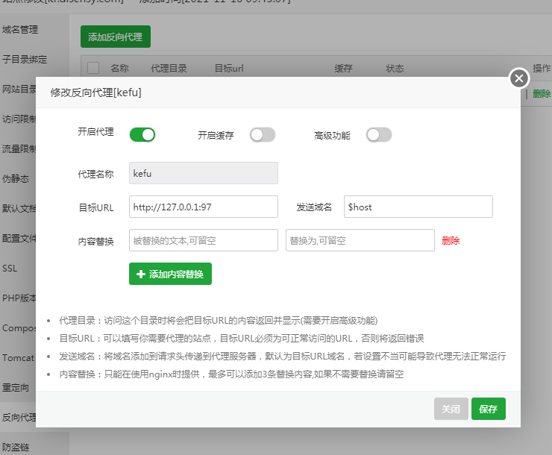

After adding, click the configuration file

Apache:
RewriteEngine On
RewriteCond %{REQUEST_URI} ^/socket.io [NC] RewriteCond %{REQUEST_URI} ^/socket.io [NC]
RewriteCond %{QUERY_STRING} transport=websocket [NC]
RewriteRule /(.*) ws://127.0.0.1:97/$1 [P,L] RewriteRule /(.*) ws://127.0.0.1:97/$1 [P,L]

Nginx: No configuration required

6. Install ffmpeg

sudo apt-get update

sudo apt-get install ffmpeg

7. Install Node.js

7.1 Install Redis in the software store.

7.2 Install PM2.

cd /usr/local

wget https://nodejs.org/dist/v10.16.3/node-v10.16.3-linux-x64.tar.xz

xz -d node-v10.16.3-linux-x64.tar.xz

tar xf node-v10.16.3-linux-x64.tar

ln -s /usr/local/node-v10.16.3-linux-x64/bin/node /usr/local/bin/node

ln -s /usr/local/node-v10.16.3-linux-x64/bin/npm /usr/local/bin/npm

ln -s /usr/local/node-v10.16.3-linux-x64/bin/npx /usr/local/bin/npx

npm install -g pm2@5.3.1

ln -s /usr/local/node-v10.16.3-linux-x64/bin/pm2 /usr/local/bin/pm2

8. ContactRTC Server Configuration

8.1 Database Configuration
sudo chmod -R 777 /www/wwwroot/kefu.rtcim.com/RTCServer
sudo chmod -R 777 /var/log
Open http://server ip:98 and configure the database.

8.2 Initiate contact for RTC server program
cd /www/wwwroot/kefu.rtcim.com/RTCServer
pm2 start processes.json
cd /www/wwwroot/cs.rtcim.com/KeFu-master
pm2 start bin/www --name kefu

8.3 Configure server address (optional)
System Tools> Background Settings> Message Server IP address: Enter https://kefu.rtcim.com and save.
Online duty-Customer service configuration-Enter https://cs.rtcim.com as the server address and save.

9. Set project startup
pm2 list
pm2 save
pm2 startup
10. Set the server to automatically restart daily or clear sessions weekly
sudo su
vim /etc/crontab
add
00 02 * * * root reboot
00 03 * * 1 root cd /www/wwwroot/kefu.rtcim.com/RTCServer/runtime/sessions && ls |xargs rm -r
00 * * * * root sudo chmod -R 777 /www/wwwroot/kefu.rtcim.com/RTCServer/public/Data
After saving, execute the following
/etc/init.d/cron restart

